**­­SHOP FOR HOME**

**Presented By (Batch C3 Group1):**

Aditya Dubey

Benarjee Atla

Chakradhar Kolli

Maddula Venkata Siva Satya Pavan Ganesh

Chakradhar Allada

Deepika Kancharakuntla

**SHOP FOR HOME**

**1.INTRODUCTION**

**1.1 MOTIVATION:**

This document aims to give a brief description about E-Commerce web application using Angular, Spring Boot and MySQL Database. The primary goal of this project is to create a website where consumers may purchase things for home décor in the event that all offline retailers collapse. E-commerce is quickly becoming a recognised and utilised business model. More and more companies are putting in place websites with capability for conducting business transactions online. It is safe to argue that doing your buying online has become routine. The goal of this project is to create a general-purpose online store where products for home décor, such as statues and idols, paintings, and other items, may be purchased. However, this document will discuss online shopping for home decor in order to facilitate implementation. A virtualized store on the Internet where clients may browse the inventory and choose items of interest is known as an online store. The chosen products might be put in a shopping basket. The goods in the shopping cart will be shown as an order when it is time to check out. At that point, more details will be required in order to finalize the purchase. Usually, the customer will be asked to give address, phone number etc. at the time of registration so that he/she can login as User and can shop in the application.

**1.2 PROBLEM STATEMENT:**

During this pandemic time it has been difficult to shop offline with the fear of spreading of corona virus. Hence many offline home décor shops have been closed due to no visitors. Almost all small businesses have been paused due to the pandemic. Hence there must be a way created for these small businesses to run even in these pandemic times so that they don’t have to bear huge loss.

Shop For Home is a popular Store in the market for shopping the home décor stuff .Due to Covid 19 all the offline shopping stopped. So, the store wants to move to the online platforms and wants their own web application.

There are 2 users on the application:

1. User

2. Admin

**1.3 SOLUTION:**

E-commerce web applications were created as a result, allowing merchants to sell their goods online and continue operating their businesses while saving buyers from having to travel.

**1.4 SCOPE OF THE PROJECT:**

Both vendors and consumers may gain greatly from online selling and buying, and these benefits are also the main drivers of e-expanding Commerce's market. According to IBEF, India's e-commerce market has a total value of USD 38.5 billion as of 2017 and is projected to reach USD 200 billion by 2026. That provides us a decent notion of the potential for e-commerce in India in the future.

**1.5 PROBLEM DEFINITION:**

E-commerce provides an easy way to sell products to a large customer base. However, there is a lot of competition among multiple e-commerce sites. When users land on an e-commerce site, they expect to find what they are looking for quickly and easily. Also, users are not sure about the brands or the actual products they want to purchase. They have a very broad idea about what they want to buy.

**1.6 OBJECTIVES:**

The primary goal of e-commerce is to reach maximum customers at the right time to increase sales and profitability of the business. Functions of e-commerce include buying and selling goods, transmitting funds or data over the internet.

The three main objectives are as follows

1. Find the best solution for their needs
2. Make a purchase, and
3. Get information/answers to their questions

**2. OVERALL DESCRIPTION**

**2.1 PRODUCT PERSPECTIVE**

The goal of a home décor business is to serve both potential customers and sellers that wish to connect with a wide range of consumers. The goal of this initiative is to close the communication gap between the supplier, the merchant, and the consumer. For the abovementioned objective, Shop for Home software should be user-friendly, "easy to learn," and trustworthy. The functionality of Shop for Home is not dependent on the presence of other software because it is designed to be a stand-alone solution. Both UNIX and Windows-based platforms should be able to run it.

**2.2 USER CLASSES AND CHARACTERISTICS**

The user should be familiar with terms used in relation to shopping malls, such as "transaction," "checking out," and "shopping cart."The user ought to be knowledgeable about the Internet.

**2.3 OPERATING ENVIRONMENT**

The system for an online store selling home decor is a website that should function in all well-known browsers. For example, consider Microsoft Internet Explorer, Google Chrome, and Mozilla Firefox. Additionally, IE 6.0 will be compatible with it. The majority of the functions will work with Mozilla Firefox and Opera 7.0 or later. The internet connection would be the sole prerequisite for using this online product. The hardware setup consists of 40GB hard disk, 15-inch colour display, and 122-key keyboard. Keyboards and mouse are the two most essential input and output devices.

**2.5 PRODUCT FUNCTIONS**

1. **User-Friendly Design**

A positive user experience is perhaps the most crucial element that buyers expect from an e-commerce site. Customers will probably quickly switch to the many other online stores if they have trouble navigating your website or finding what they're searching for. Use recommended e-commerce UX techniques. Focus on improving the user experience by making a clean, clear, high-quality homepage. with a search bar included. The navigation bar clearly lists the category pages and putting emphasis on developing a responsive website.

1. **Mobile-Friendly Features**

Consumers who shop online nowadays are becoming more and more dependent on their mobile devices. In 2020, mobile devices accounted for 56% of all online purchases, according to SaleCycle. In other words, the majority of buyers prefer to explore online stores on their phones, thus it's crucial to incorporate mobile optimization into the design of your e-commerce website. To improve your conversion rate and keep clients satisfied, make sure your website design is automatically adjusted for the size and form of phones.

1. **Multiple Payment Options**

For online merchants, shopping cart abandonment is frequently a major problem. Make the purchase process as simple as possible for your consumers by including a variety of online payment options in the shopping cart. This will increase your chances of closing the sale during the final checkout step on your website. Add options for payment services like PayPal or Stripe in addition to providing debit and credit card choices. To encourage users to click the "purchase" button, you may also provide plugins with a buy now, pay later feature.

1. **24/7 Customer Service**

Providing friendly, approachable customer service is crucial to a positive client experience. Microsoft estimates that 90% of Americans give customer service a high priority when choosing whether or not to make a purchase from a business. One of the features on your e-commerce website should be a 24/7 chatbot for customer care to respond to requests at any time. For a nominal charge, you can easily add this option to your website using plugins like Zendesk or LivePerson.

1. **User Discounts Customers**

Customers enjoy believing that they are receiving a good bargain and are being treated differently from other customers. To provide customers with this kind of alluring, tailored experience, provide customised bargains, offers, and other user benefits.Create user profiles for consumers so they may enjoy loyalty discounts, a personalised wishlist, and account history. To deliver targeted special offers to devoted consumers, you may also employ an automated emailing system on an e-commerce platform.

1. **Extensive Product Information**

Although internet shopping has grown quite popular, many customers still have reservations about making purchases, especially from smaller firms they may not be acquainted with.For customers, not being able to see or sample a thing before buying it is a major drawback of internet purchasing.Make sure to include as much product information as you can in order to persuade your clients that your product is of a good calibre and is worth their money.

**2.6 Appropriation of Requirements**

As stated by the customer, security is not a concern of this project. As such, it is beyond the scope of this system to encrypt personal user data, encrypt credit card information, prevent unauthorized login attempts, or any other concern of this nature. Additionally, the system is not responsible for the following:

• Verifying that credit card information is valid

• Verifying the email address provided by a user

• Storing additional information about a product beyond simply the category and price • Allowing users to edit their account details (username, password, mailing address, etc)

• Allowing customers to order multiple copies of product in a single order

• Providing individual product description

• Allowing the Admin to update login credentials or other information about the Admin.

**3. SPECIFIC REQUIREMENTS**

**3.1 FUNCTIONAL REQUIREMENTS**

**User Stories –**

1. As a user I should be able to login, Logout and Register into the application.
2. As a user I should be able to see the products in different categories.
3. As a user I should be able to sort the products.
4. As a user I should be able to add the products into the shopping cart.
5. As a user I should be able to increase or decrease the quantity added in the cart.
6. As a user I should be able to add “n” number of products in the cart.
7. As a user I should be able to get the Wish list option where I can add those products which I want but don’t want to order now.
8. As a user I should get different discount coupons.

**Admin Stories –**

1. As an Admin I should be able to login, Logout and Register into the application.
2. As an Admin I should be able to perform CRUD on Users.
3. As an Admin I should be able to Perform CRUD on the products.
4. As an Admin I should be able to get bulk upload option to upload a csv for products details
5. As an Admin I should be able to get the stocks.
6. As an Admin I should be able to mail if any stock is less than10.
7. As an Admin I should be able to get the sales report of a specific duration.
8. As an Admin I should be able to set the discount coupons for the specific set of users

**3.2 SOFTWARE REQUIREMENTS:**

The functional requirements or the overall description documents include the product perspective and features, operating system and operating environment, graphics requirements, design constraints and user documentation. The appropriation of requirements and implementation constraints gives the general overview of the project in regards to what the areas of strength and deficit are and how to tackle them.

| **Technologies** | **Angular, Spring Boot, MySQL** |
| --- | --- |
| **Languages** | **Type Script, Java, SQL,HTML,CSS** |
| **IDE** | Eclipse , VS code, MySQL |
| **Operating System** | Windows 7/8/10/11 , Linux distros, MacOS X or later. |

**3.3 HARDWARE REQUIREMENTS:**

The bare minimum hardware needs vary greatly depending on the software an Enthought Python/VS Code user is working on. Apps that need to execute several computations or operations rapidly will need a faster CPU, but applications that need to store big arrays of objects in memory would need more RAM.

| **Processor** | Intel or AMD dual core x86 processor. |
| --- | --- |
| **Ram** | 4 GB or above. |
| **Hard disk** | 500 MB of free disk space or more. |

**3.3 ARCHITECTURE**

**Angular Architecture:**

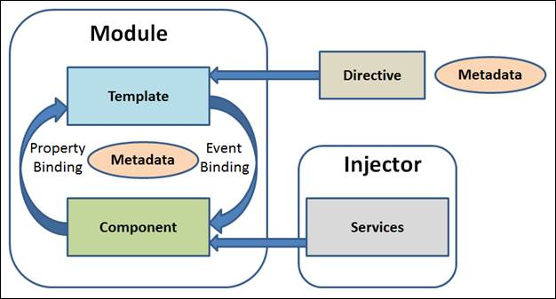

**Fig. 3.1 Angular Architecture**

There are main eight blocks of Angular.

1. Module
2. Component
3. Metadata
4. Template
5. Data Binding
6. Service
7. Directive
8. Dependency Injection

**Spring Boot Architecture:**

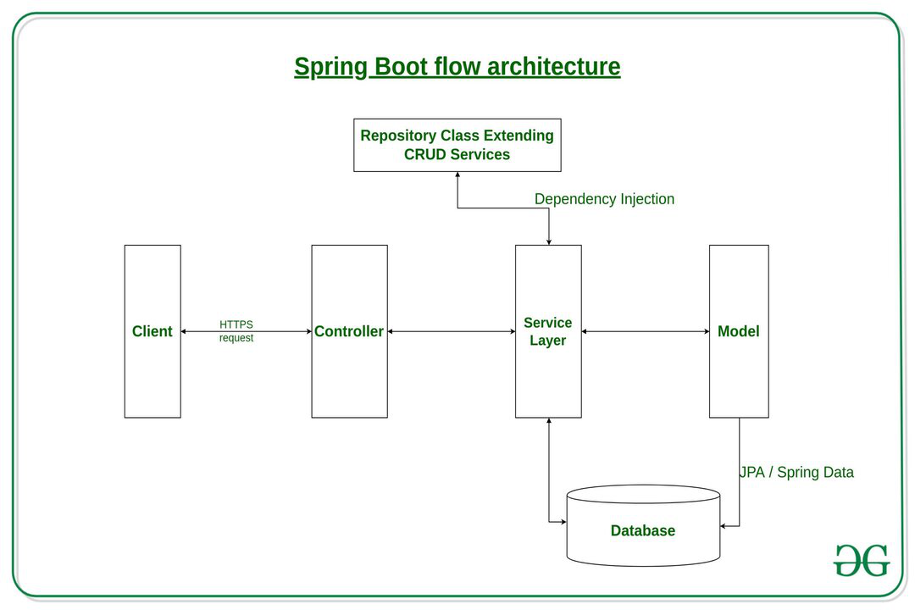

**Fig. 3.2 Spring Boot Architecture**

The spring boot consists of the following four layers:

1. Presentation Layer – Authentication & Json Translation
2. Business Layer – Business Logic, Validation & Authorization
3. Persistence Layer – Storage Logic
4. Database Layer – Actual Database

**Micro Services Architecture**

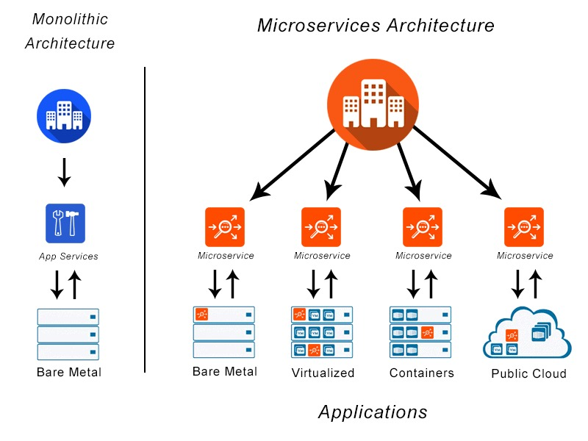

**Fig 3.3 Microservices Architecture**

Typically, microservices are used to speed up application development. Microservices architectures built using Java are common, especially Spring Boot ones. It’s also common to compare microservices versus service-oriented architecture. Both have the same objective, which is to break up monolithic applications into smaller components, but they have different approaches

**Project Architecture**

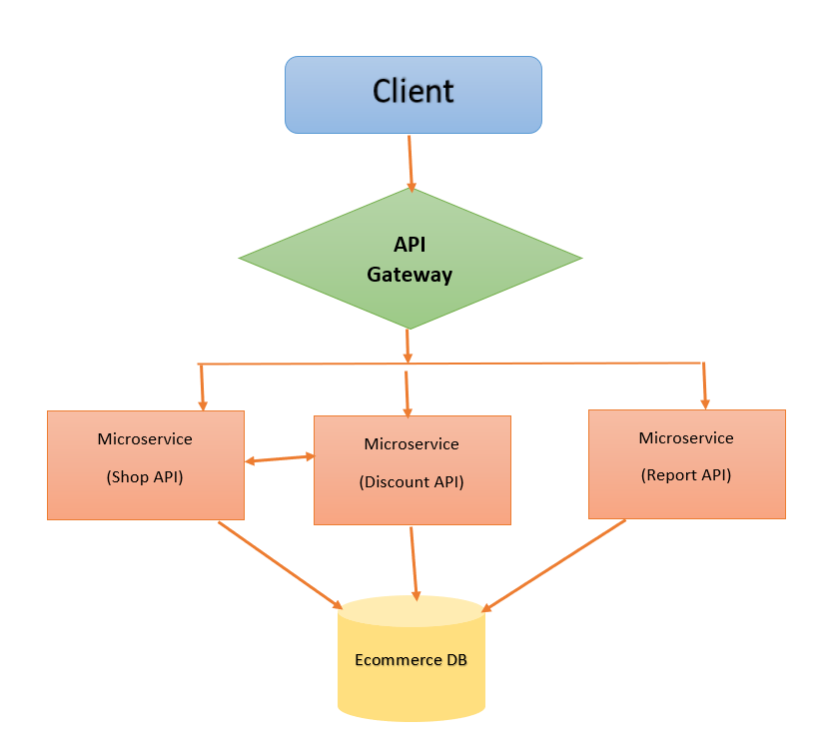

**Fig 3.4 Project Architecture**

**API Gateway**.

The API gateway is the entry point for clients. Instead of calling services directly, clients call the API gateway, which forwards the call to the appropriate services on the back end.

Advantages of using an API gateway include:

* It decouples clients from services. Services can be versioned or refactored without needing to update all of the clients.
* Services can use messaging protocols that are not web friendly, such as AMQP.
* The API Gateway can perform other cross-cutting functions such as authentication, logging, SSL termination, and load balancing.
* Out-of-the-box policies, like for throttling, caching, transformation, or validation.

**Shop Microservice**

Shop Microservice contains business logic and functionalities related to product view page, Cart, Checkout and User login Features. It connects to ecommerce DB (MySQL).

This service runs with port number 8080 in this application.

**Discount Microservice**

Discount Microservice contains business logic and functionalities for discount and coupon list Features. Admin can add and delete coupons from Discount UI from Admin module. It connects to ecommerce DB (MySQL). This service configured with application properties which runs the service in port number 8081 in this application.

**Report Microservice**

Report Microservice contains business logic and functionalities for report download option. Admin can download the stocks report as an excel file from Admin module. It connects to ecommerce DB (MySQL). This service configured with application properties which runs the service in port number 8082 in this application.

**Eureka Server For Microservice**

Eureka Server is service discovery for your microservices, where all client applications can register by themselves and other microservices look up the Eureka Server to get independent microservices to get the job complete.

Eureka Server is also known as Discovery Server and it contains all the information about client microservices running on which IP address and port.

To achieve this you need to create a Eureka Server application and add the below dependency in POM.xml.

1

<dependency>

<groupId>org.springframework.cloud</groupId>

<artifactId>spring-cloud-starter-netflix-eureka-server</artifactId>

</dependency>

* **spring.application.name** is a unique name for your application.
* **server.port** in which your application will be bound and wewill use default port 8761 for eureka server.
* **eureka.client.fetch-registry** doesn't register itself in eureka server.
* **eureka.client.register-with-eureka** is determines if service register itself as a client in eureka server.

**Running the Eureka Server**

Run the Eureka server as Java application and go the URL: http://localhost:8761/

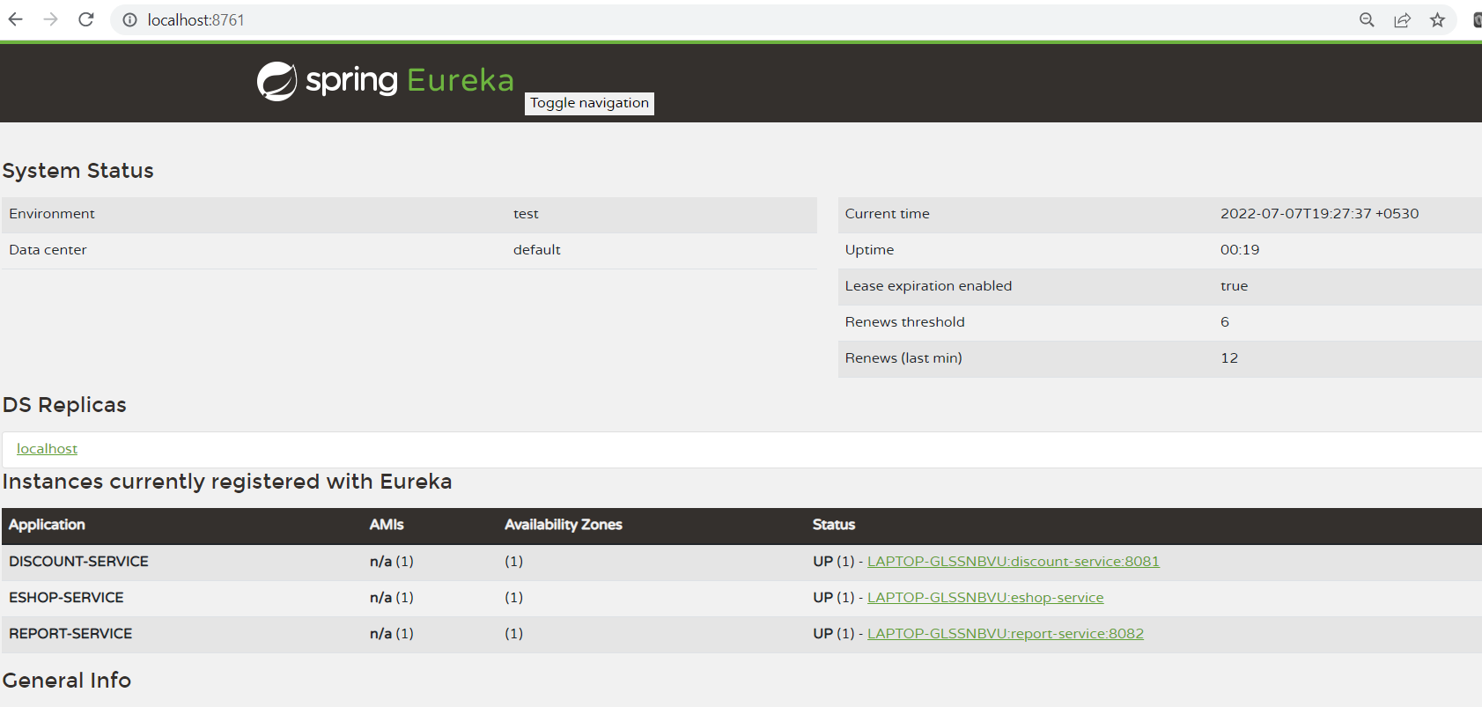

**DataBase Design:**

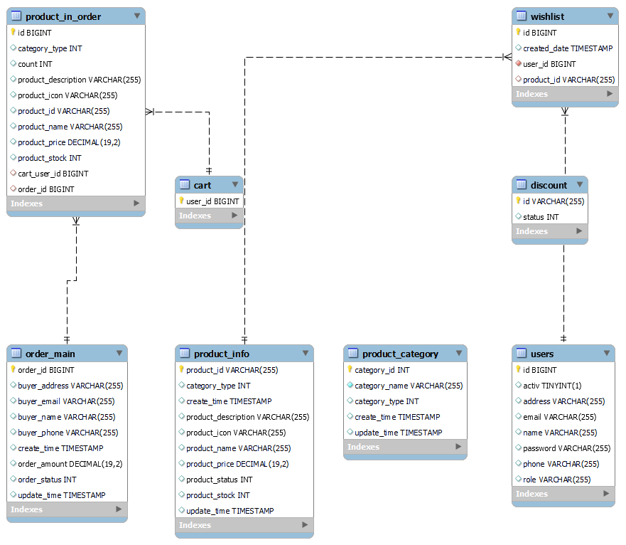

Fig. Tables created in Mysql database

Entities in the Database include

1. Product_Category
2. Product_info
3. Cart
4. Users
5. product_in_order
6. Order_main
7. Discount
8. Wishlist

**3.3 NON FUNCTIONAL REQUIREMENTS**

### **Usability:**

Regardless of the size of your business, the website of your business should be easy to use for even a non-technical user. Do you know that a general user takes just 0.05 seconds to figure out whether the website is worth its time or not? Thus you have to give special attention to the design of your homepage, CTAs, and easy checkout to get past those milliseconds of doom. The usability of a website is also defined by:

* How easily a user can achieve their target in a single page visit
* How quickly they can perform tasks in the store
* The memorable & intuitiveness of the design
* Number and types of errors users make

### **Security:**

If your website handles financial transactions, user financial information, or other sensitive information, security is of the highest significance. The adoption of an SSL certificate and a data privacy policy will increase consumer confidence in your website and turn visitors into brand promoters. Additionally, it is taken into account for the various admin roles that help you manage who may create, see, copy, update, and remove content. Depending on where your company is located, security might also include adhering to laws governing the protection of client data, like the GDPR in Europe.

### **Performance:**

You must pay close attention to performance in the non-functional requirements documents if you want to increase website traffic. Regardless of the quantity of integrations and the volume of visitors on your website, the emphasis should be on loading the e-commerce shop as quickly as feasible. You may choose the maximum number of SKUs you wish to add, the benchmark speed, or any other performance metric that works best for your company. Because the developers won't have control over the third party API requests, don't take into account the delivery time of the third party system.

1. **Maintainability:**

The most challenging aspect of creating a business budget is accounting for maintenance operations expenditures. By including website maintenance into the process from the beginning, future system errors may be found and fixed with less time and expense. Unfortunately, there is no way to prevent problems from arising in the future, therefore you must search for a website building business that can handle website maintenance.

1. **Scalability:**

Last but not least, you need to consider scalability while searching for a solution that will be reliable in the future. It will outline how the website may expand and add features and functionality without affecting how well your website functions. For your website to handle additional transactions, you must be able to add extra RAM, servers, or disc space. You might need to implement localization tools on the server side as you expand into new markets. Overall, this NFR allows for easy corporate growth and has ramifications for both hardware and software.

**4.MODELING REQUIREMENTS**

**4.1 UML DIAGRAMS :**

Unified Modeling Language is known as UML. A general-purpose modelling language with standards, UML is used in the field of object-oriented software engineering. The Object Management Group oversees and developed the standard.

The objective is for UML to establish itself as a standard language for modelling object-oriented computer programmes. UML now consists of two main parts: a notation and a meta-model. In the future, UML may potentially be coupled with or added to in the form of a method or process.

A common language for describing, visualising, building, and documenting the artefacts of software systems as well as for business modelling and other non-software systems is the Unified Modeling Language.

The UML is a set of best engineering principles that have been successful in simulating big, complicated systems.

The process of creating objects-oriented software and the software development process both heavily rely on the UML. To express the design of software projects, the UML primarily employs graphical notations.

GOALS:

The Primary goals in the design of the UML are as follows:

1. Provide users a ready-to-use, expressive visual modeling Language so that they can develop and exchange meaningful models.

2. Provide extendibility and specialization mechanisms to extend the core concepts.

3. Be independent of particular programming languages and development processes.

4. Provide a formal basis for understanding the modeling language.

5. Encourage the growth of the tools market.

6. Support higher level development concepts such as collaborations, frameworks, patterns and components.

7. Integrate best practices

**4.1.1 USE CASE DIAGRAM**

A use case diagram in the Unified Modeling Language (UML) is a type of behavioral diagram defined by and created from a Use-case analysis. Its purpose is to present a graphical overview of the functionality provided by a system in terms of actors, their goals (represented as use cases), and any dependencies between those use cases.

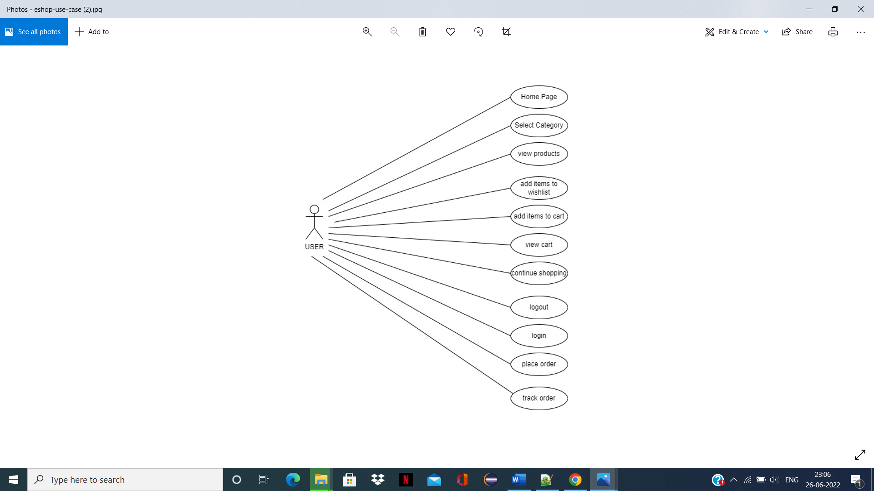

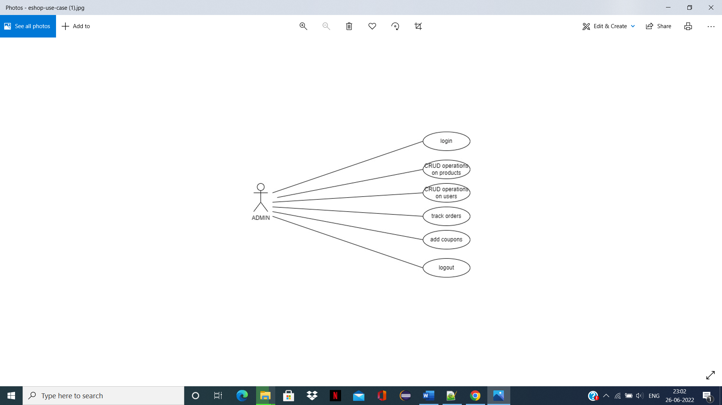

**Fig. 4.1 Use Case Diagram**

**4.1.2 CLASS DIAGRAM**

The class diagram is used to refine the use case diagram and define a detailed design of the system. The class diagram classifies the actors defined in the use case diagram into a set of interrelated classes. The relationship or association between the classes can be either an "is-a" or "has-a" relationship. Each class in the class diagram may be capable of providing certain functionalities. These functionalities provided by the class are termed "methods" of the class.

Apart from this, each class may have certain "attributes" that uniquely identify the class.



**Fig. 4.2 Class Diagram**

**4.1.3 STATE CHART DIAGRAM**

A state diagram, as the name suggests, represents the different states that objects in the system undergo during their life cycle. Objects in the system change states in response to events. In addition to this, a state diagram also captures the transition of the object's state from an initial state to a final state in response to events affecting the system.

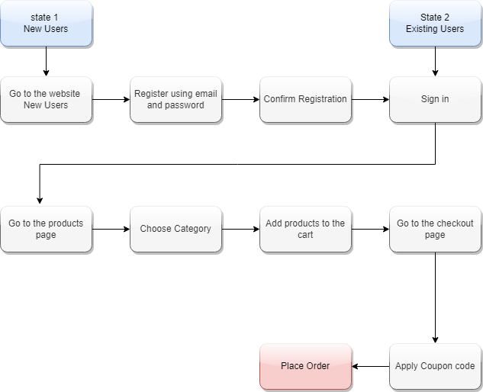

**Fig. 4.3 State Chart Diagram**

**4.1.4 SEQUENCE DIAGRAM :**

A sequence diagram shows how various system items interact with one another. The fact that a sequence diagram is time-ordered is crucial. This indicates that the precise order of the objects' interactions is displayed step by step. The sequence diagram shows how various things communicate with one another by sending "messages."

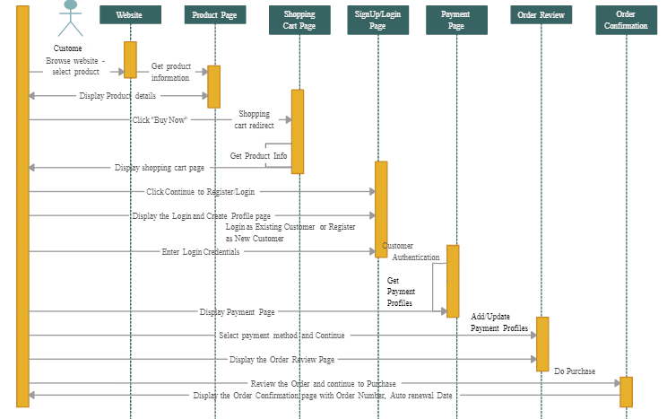**Fig. 4.4 Sequence Diagram**

**4.1.5 DATA FLOW DIAGRAM**

The flow chart diagram is a special kind of class diagram. The flow chart diagram depicts the flow of the process or algorithm using a set of symbols. The flow chart diagram is a pictorial representation of the algorithm or working of the algorithm.

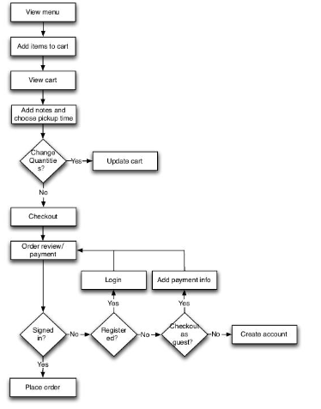

**Fig 4.5 Data Flow Diagram**

**5. IMPLEMENTATION**

We will implement a simple e-commerce application. We'll develop an API using Spring Boot and a client application that will consume the API using Angular. Basically, the user will be able to add/remove products from a product list to/from a shopping cart and to place an order.

**5.1 TECHNOLOGY USED**

In below we would like to explain which technologies are used in this project. It’s helpful for understand the project layouts & overview of documentation.

### **Back-end**

1. Java
2. Spring Boot
3. Spring Security
4. JWT
5. Hibernate
6. MySQL
7. Maven

### **Front-end**

1. Angular
2. Bootstrap
   1. **IMPLEMENTATION STEPS**

First you need to start back-end server, after that execute client side. Follow below steps to run this application on your system.

First Install all the prerequisite softwares like Java 11 jdk, VS code editor, Eclipse, MySQL.

Database:

1. Install Mysql workbench
2. Open that Mysql
3. Open this query editor and You can run the query from sql file.
4. Run the query.

Backend:

1. Open Eclipse IDE
2. Create Spring boot applications for main backend part, microservice based structure i.e Eureka Server ,Discount and report microservices by adding required dependencies.
3. Download and Extract the jar files into local directory.
4. Import the extracted jar files into eclipse IDE and run the applications one by one as Java application.

Frontend:

1. From your local FrontEnd code path -> open cmd

Eg -> {local path}\ecommerce-eshop\frontend

1. Run this command -- **code .**
2. Run **Npm install** from vs code terminal
3. Run npm start
4. After the successful compiling you got this link in terminal localhost/4200.
5. Open this link in google chrome.

**6. RESULT AND DISCUSSION**

**FRONT END SCRENSHOTS**

FRONT END STRUCTURE:

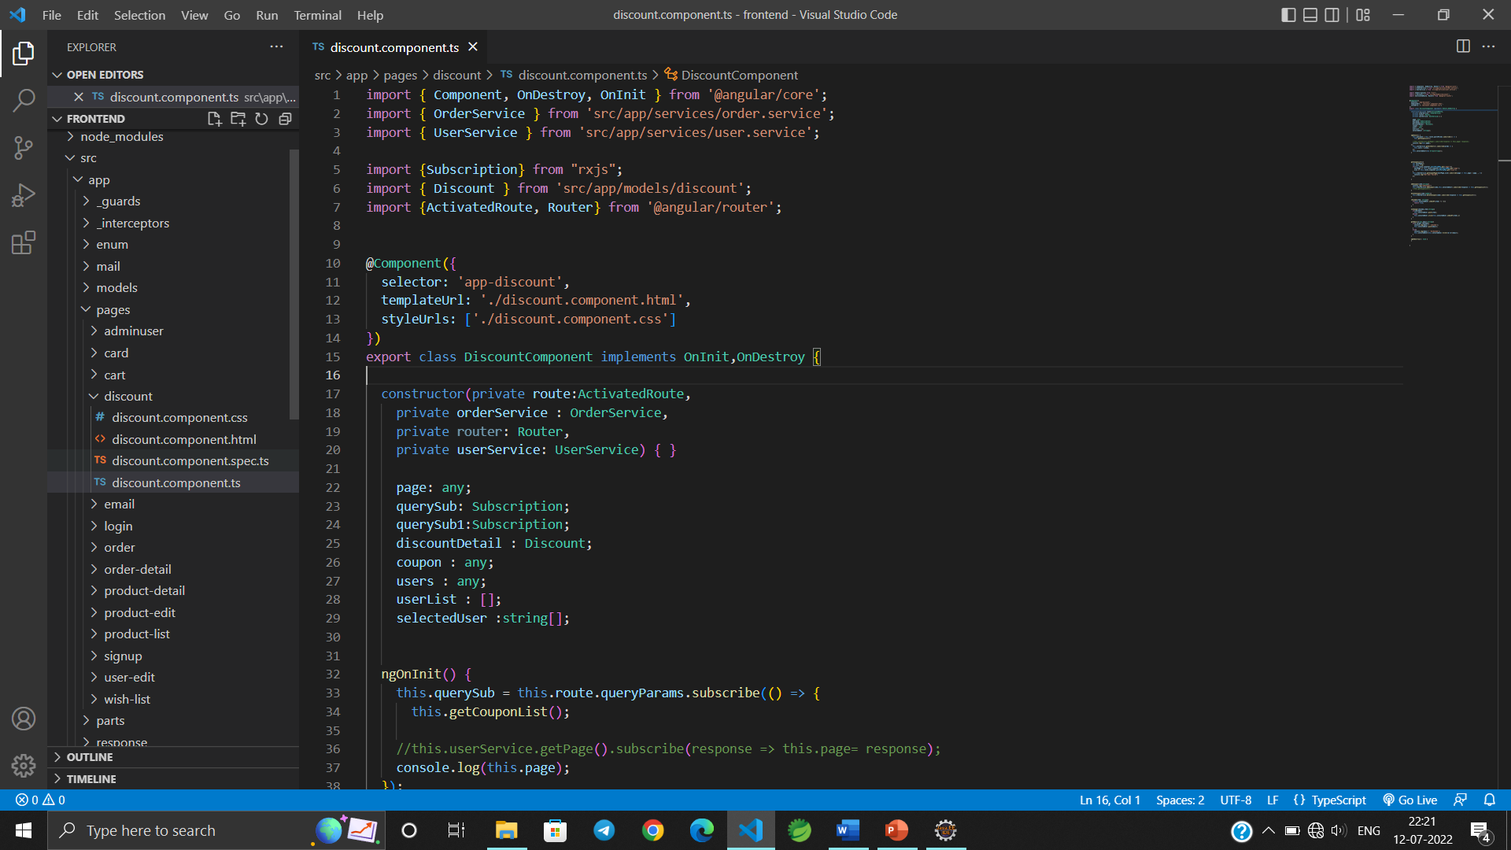

VS Code page

**USER FUNCTIONALITY:**

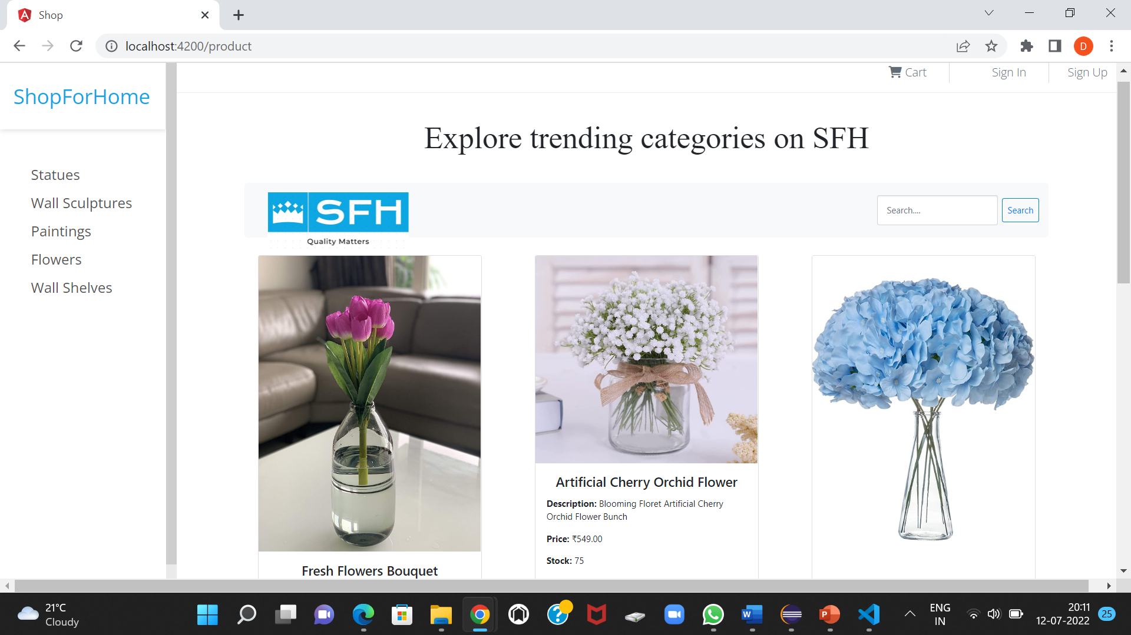

Home page

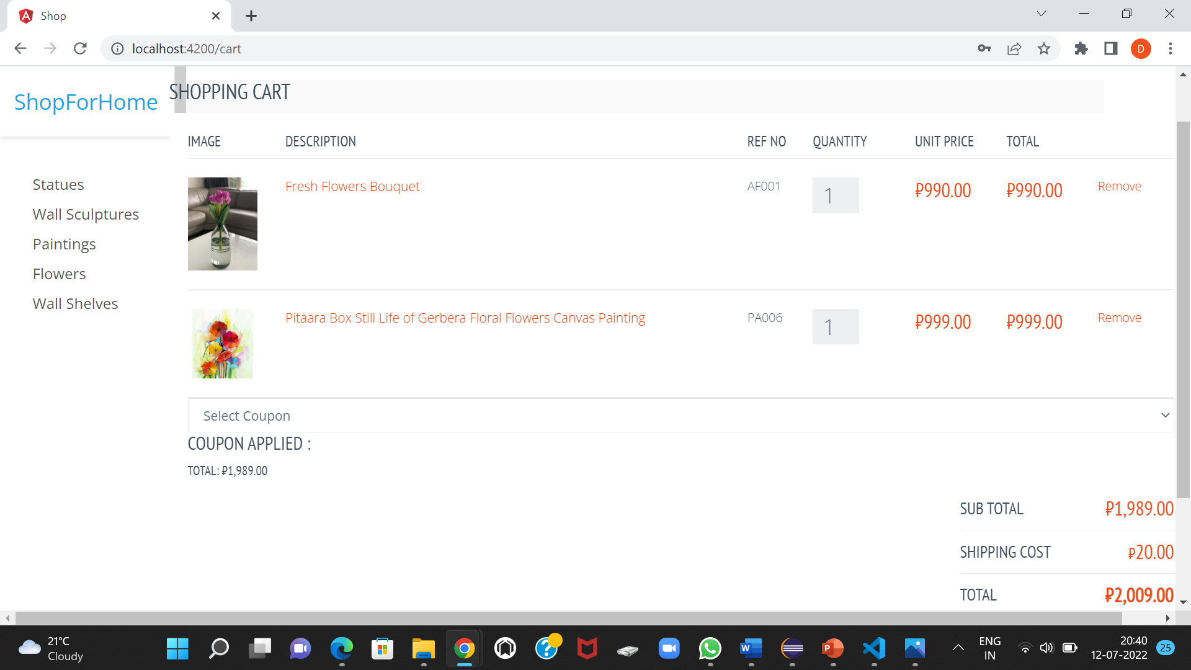

Cart page

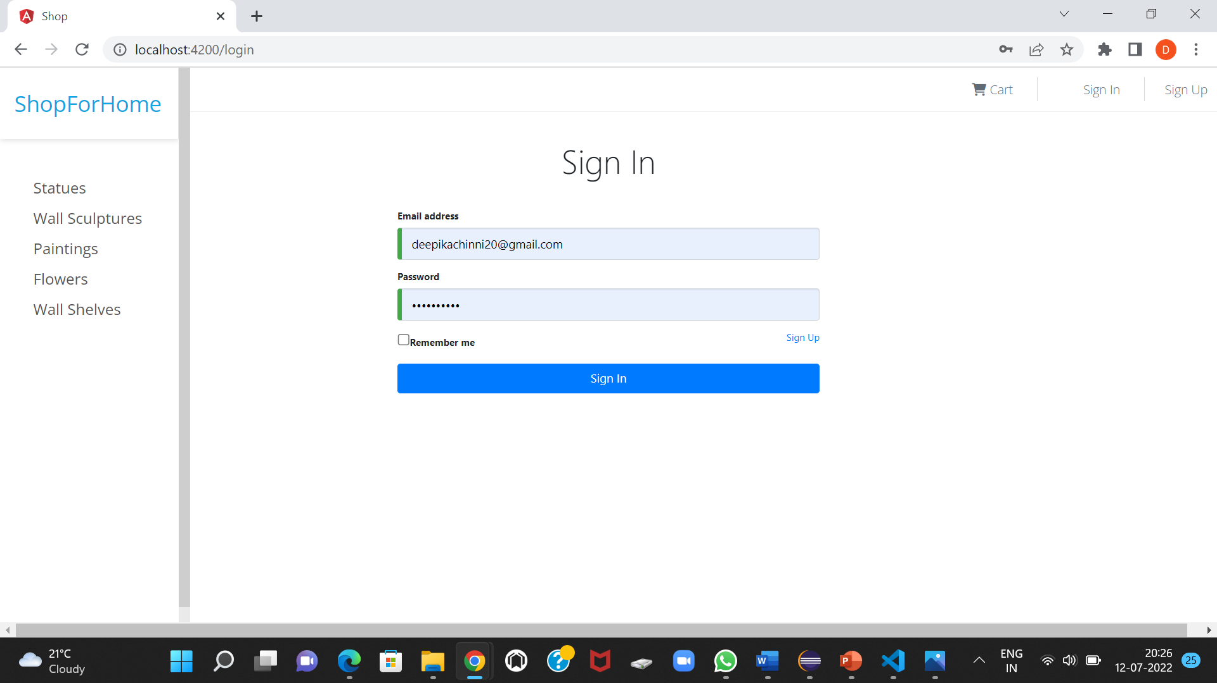

Sign In page

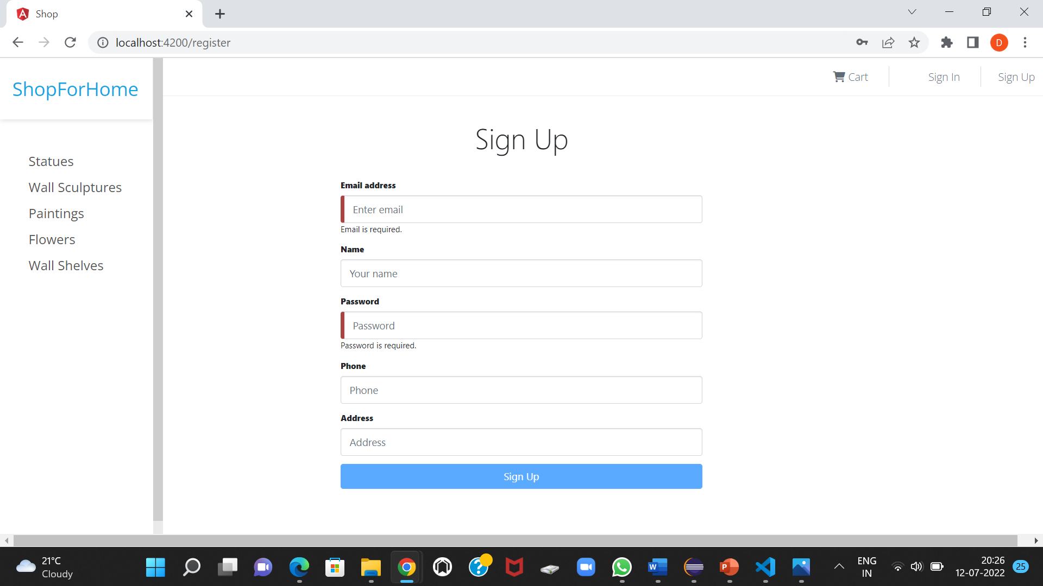

Sign Up page

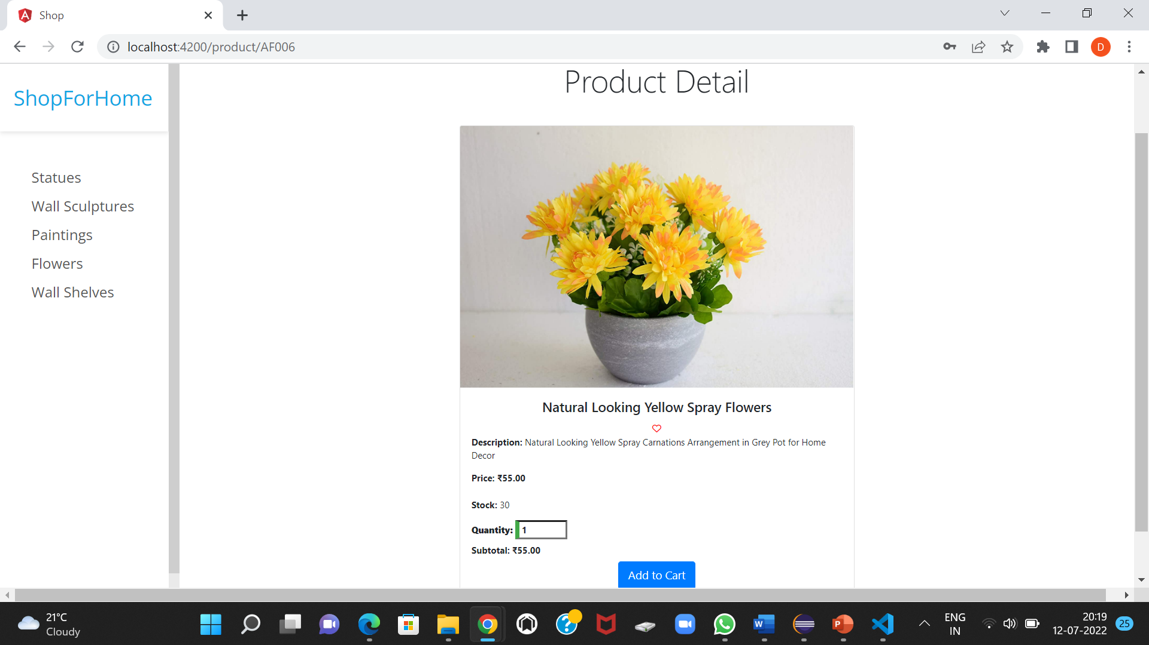

Product Details page

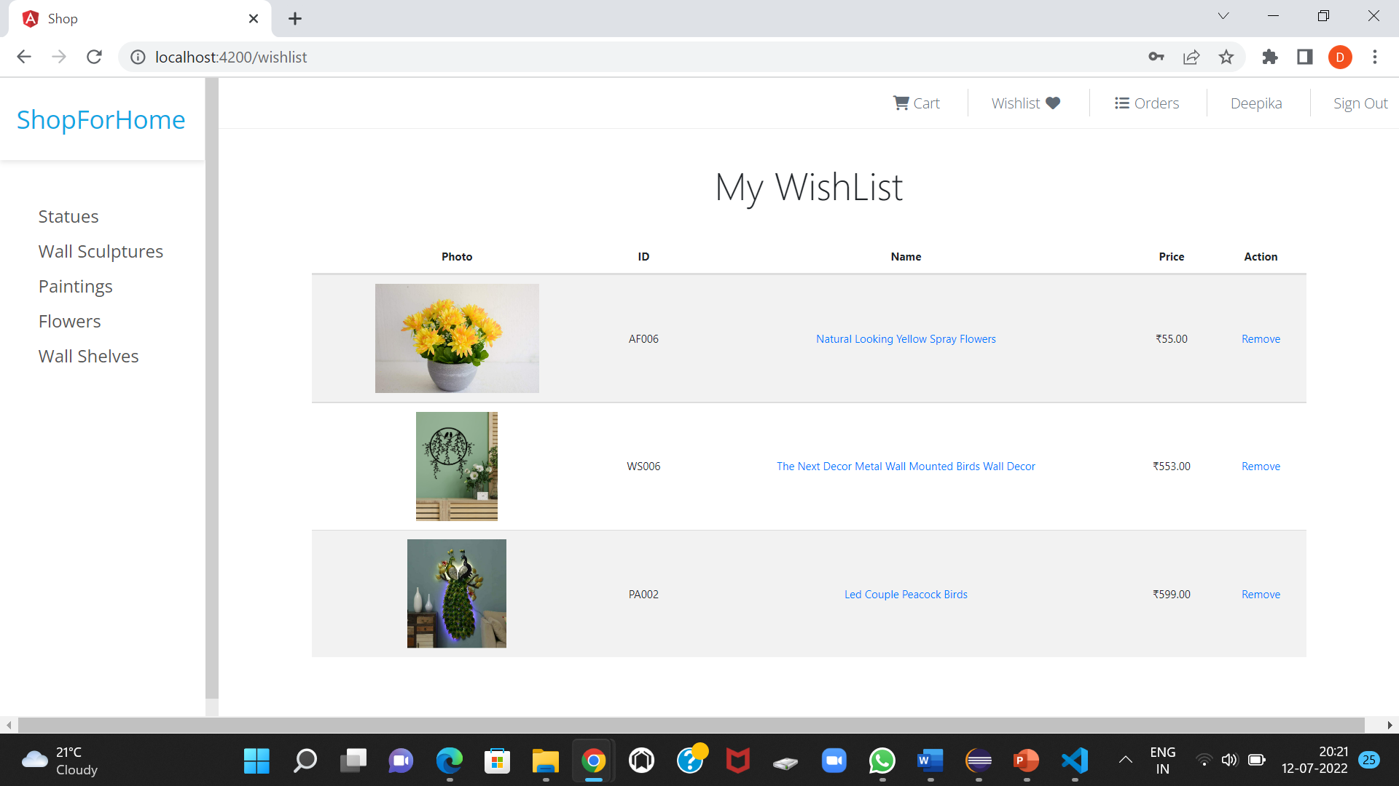

WishList page

ADMIN FUNCTIONALITY:

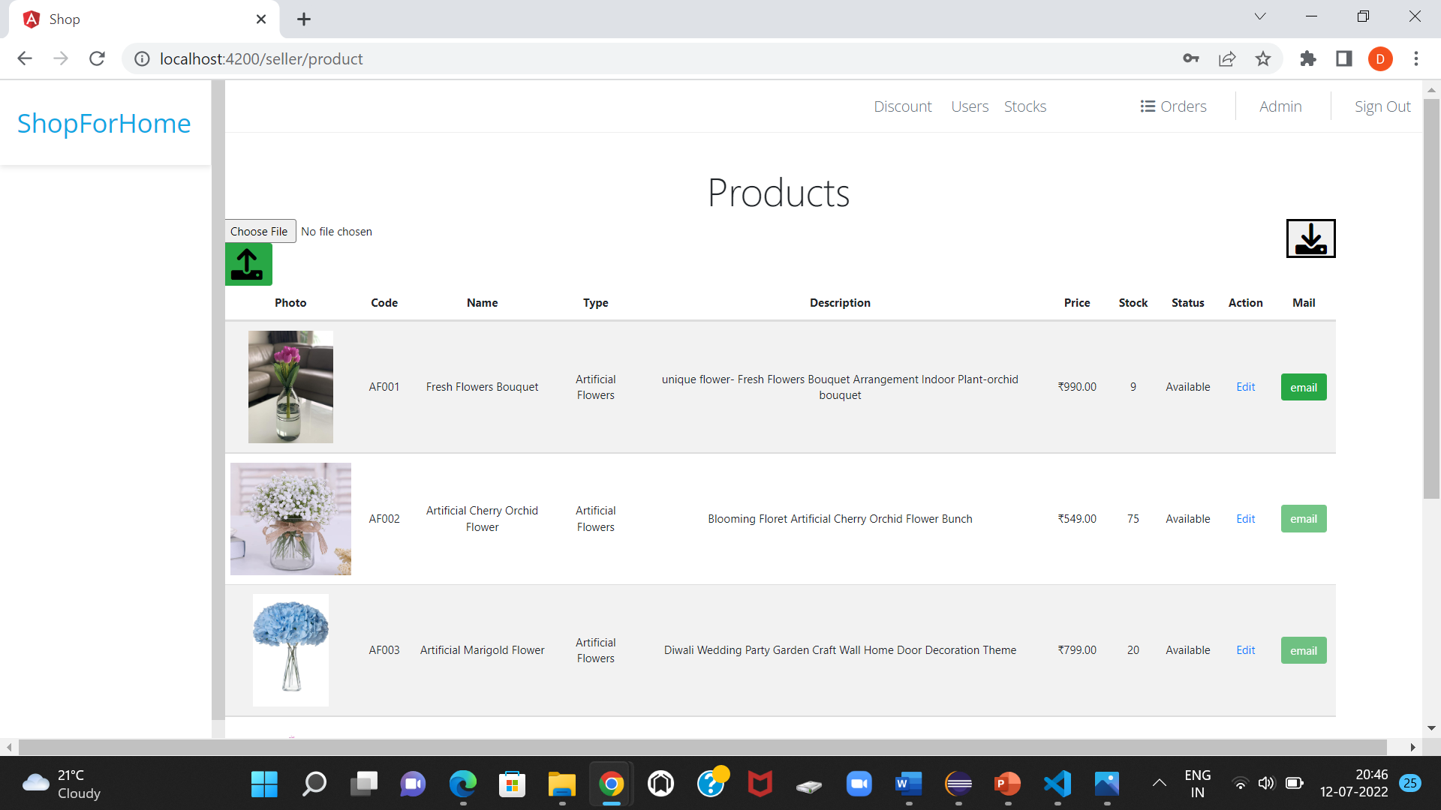

Stock page

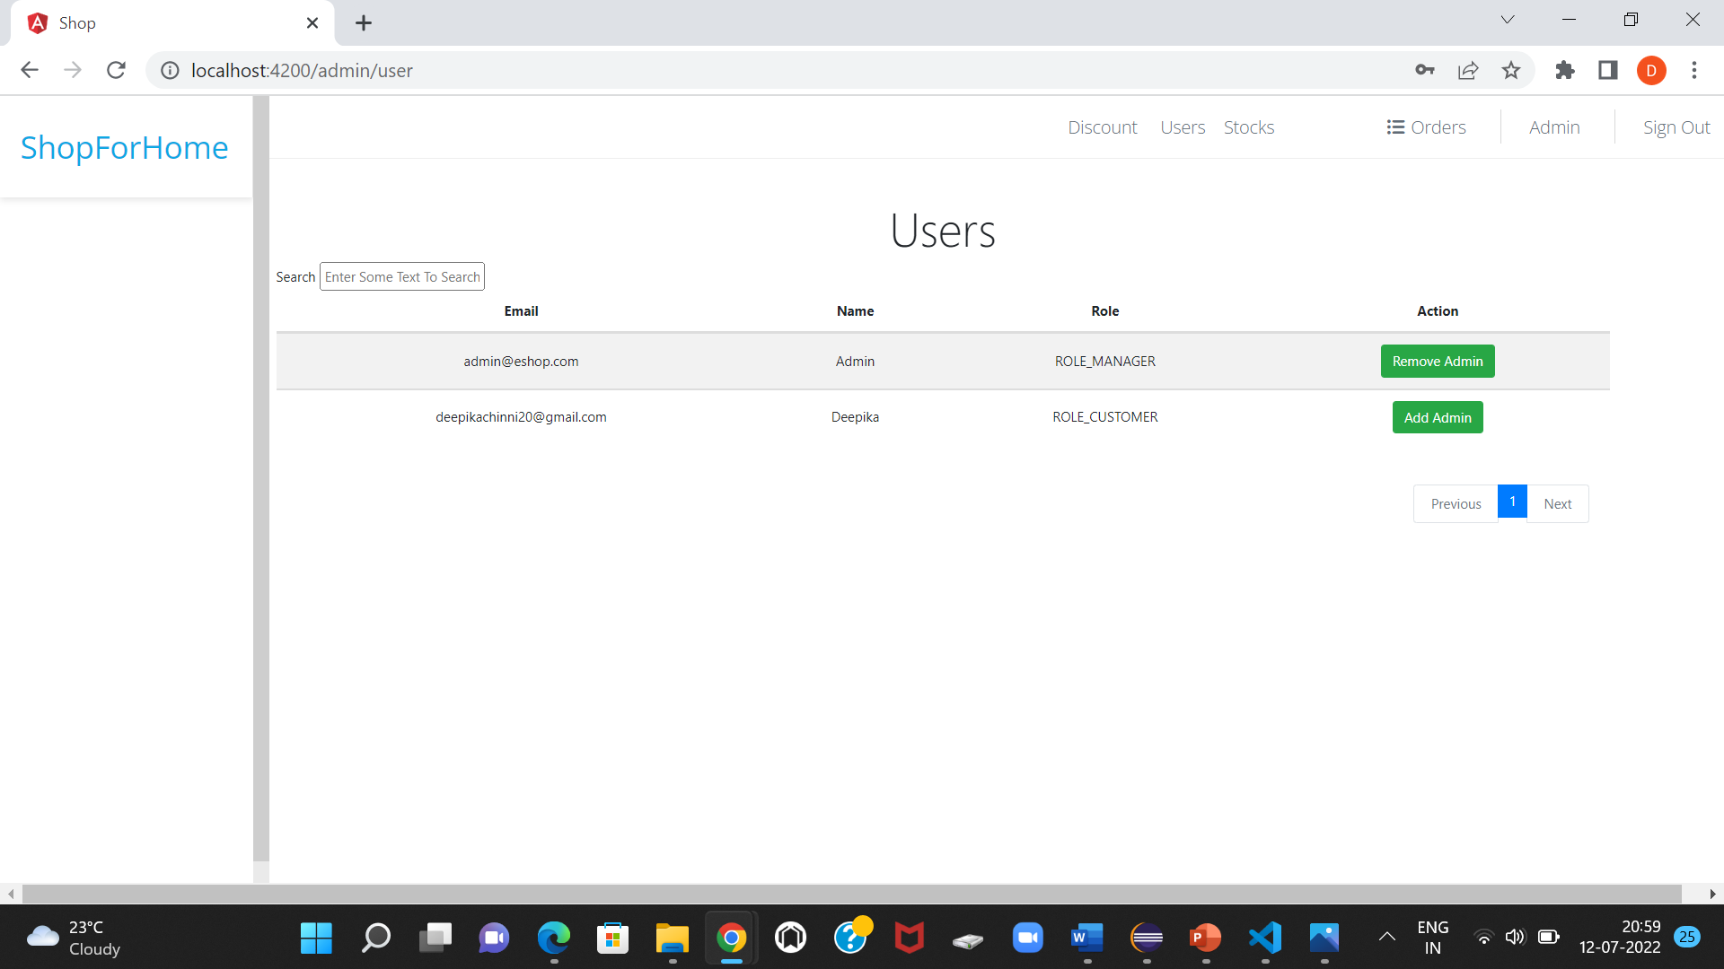

User view page

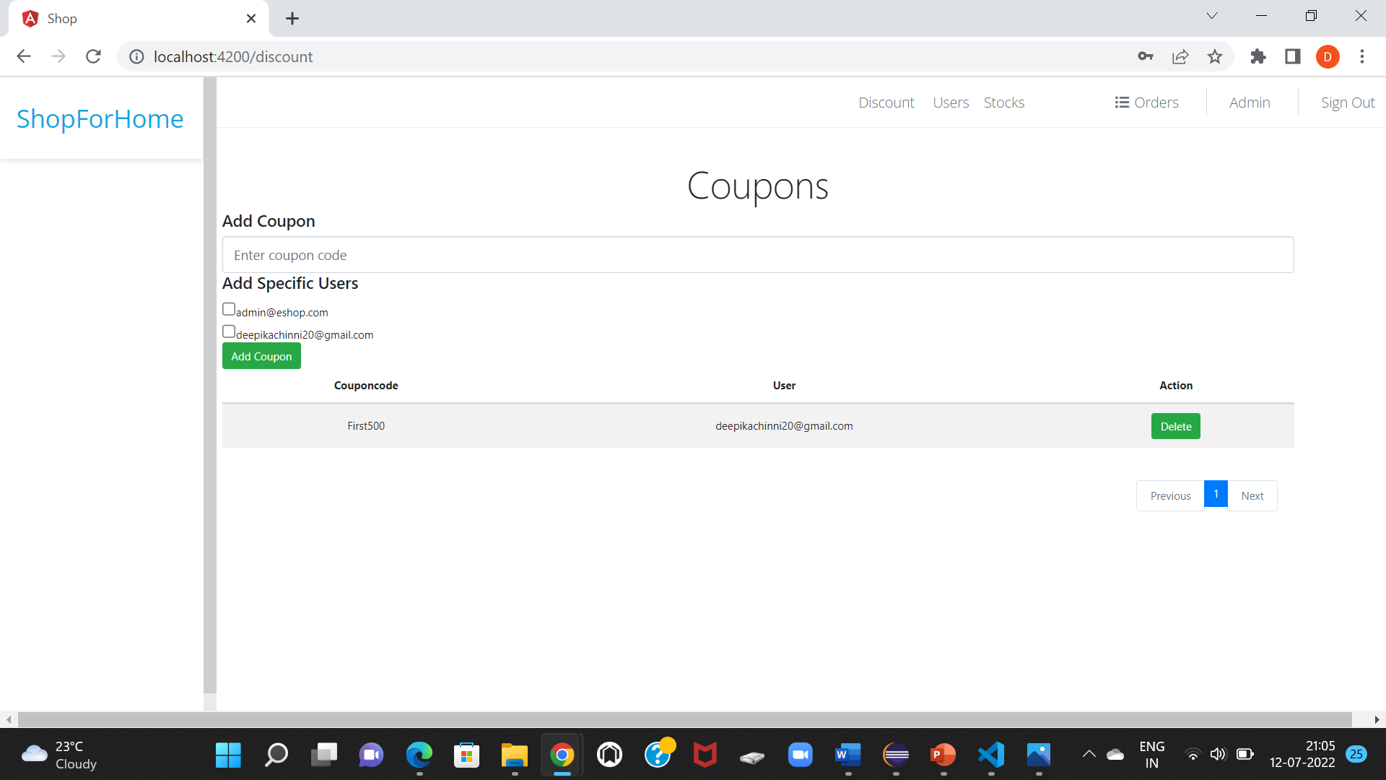

Discount page

**BACKEND SCREENSHOTS**

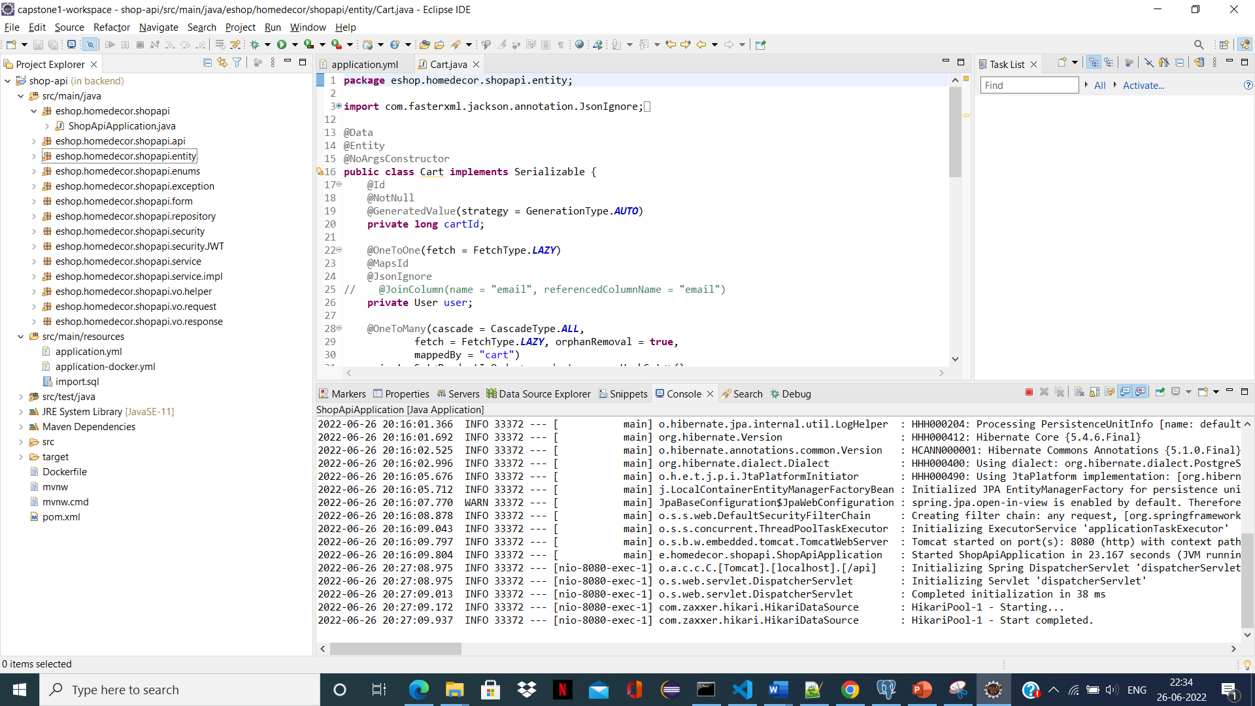

Backend Structure

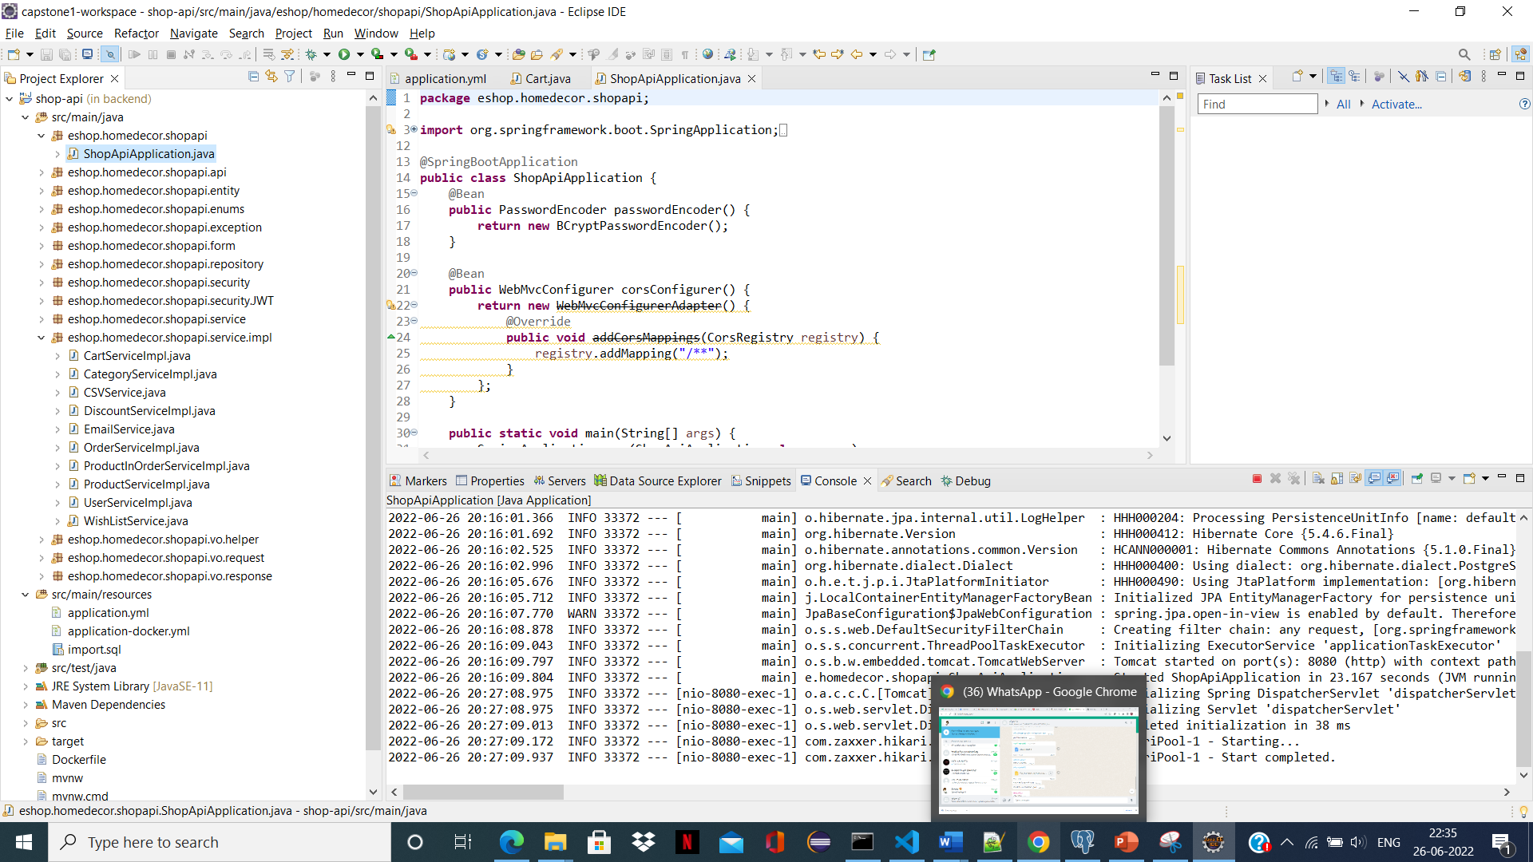

Service page

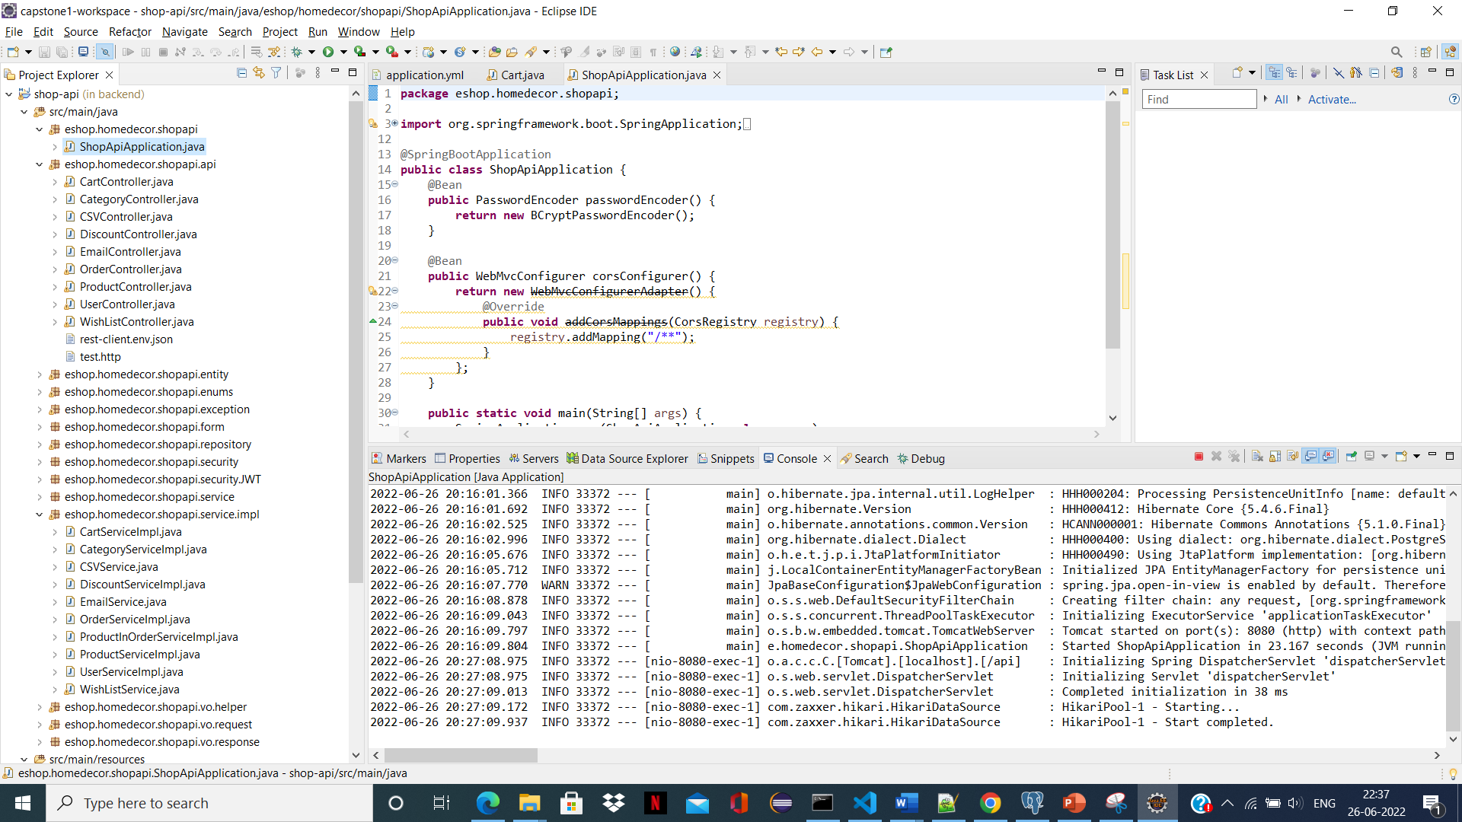

Api page

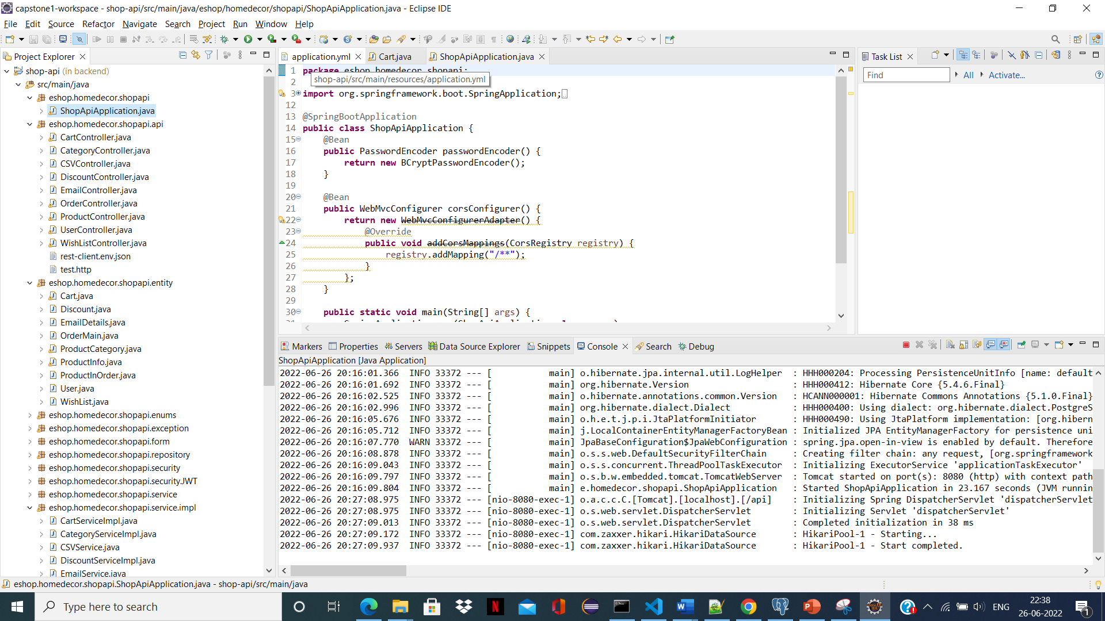

Entity page

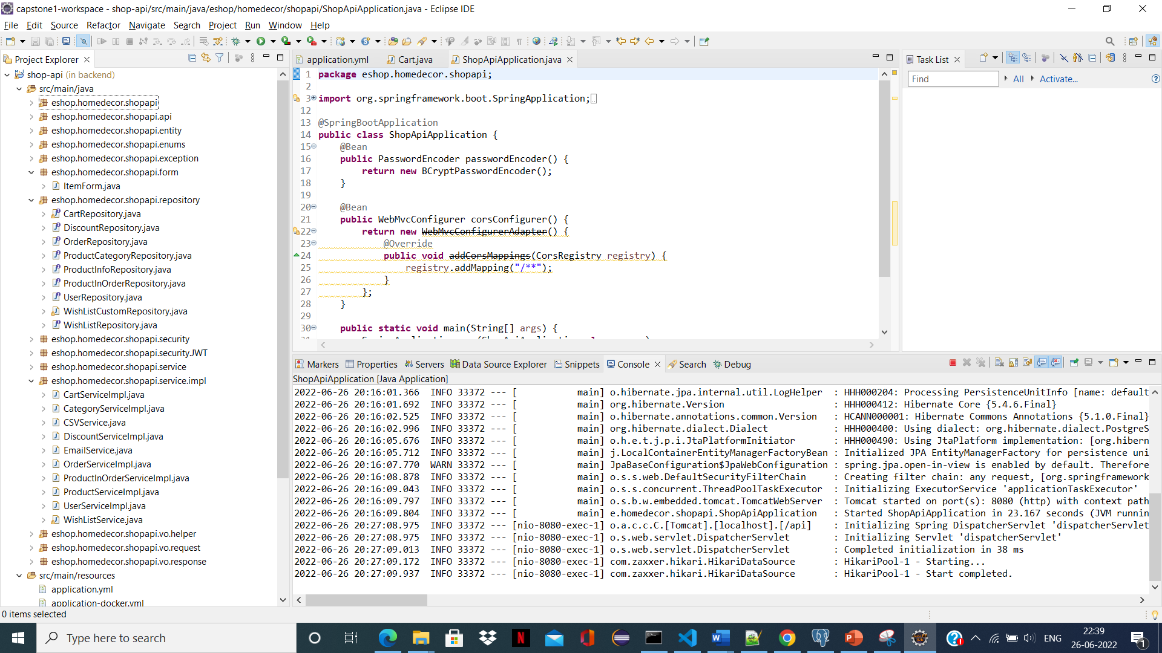

Repository page

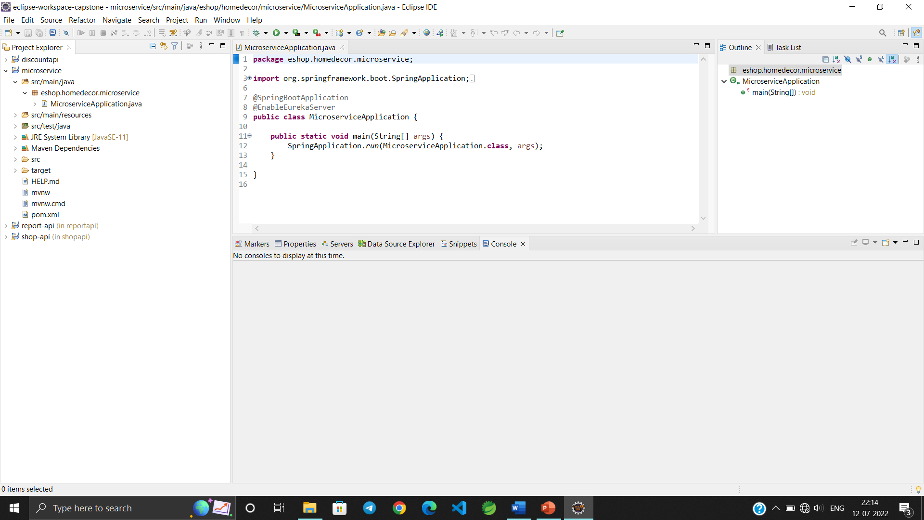

Microservice Based Structure

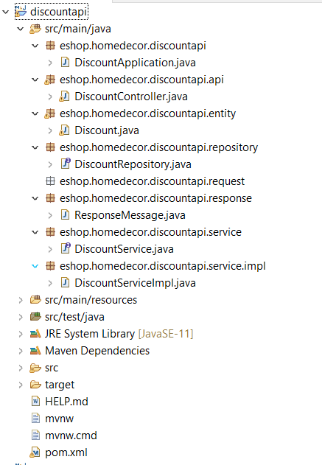

Discount Microservice

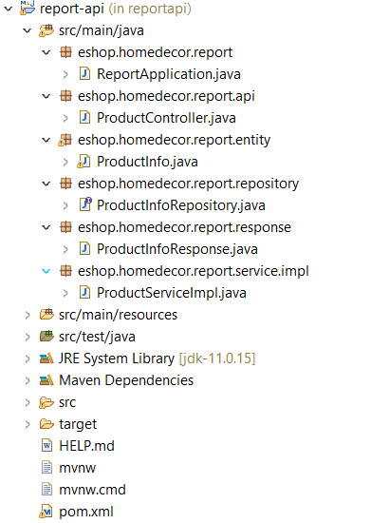

Report Microservice

**8. CONCLUSION AND FUTURE SCOPE**

E-commerce has unquestionably risen to prominence in our culture. Future-proof businesses will be those that take e-commerce seriously and invest enough money in its expansion. E-commerce is a whole-business endeavour rather than an IT problem. The businesses that utilise it as an excuse to change their operational procedures stand to gain the most. E-commerce is also a useful technology that gives customers access to businesses and organisations throughout the globe.

Despite a number of obstacles, the eCommerce sector has a lot of potential. The success of e-commerce enterprises is greatly influenced by social media since customers use these platforms to keep informed. We anticipate that the usage of drones will transform how the eCommerce industry operates in the future. The products might be delivered to the customer's door on the same day as the order was placed with its assistance. Everyone has a mobile phone these days, which has boosted the development of new eCommerce business apps. In order to interact with customers, many businesses are converting to an app-only strategy.

**REFERENCES**

[1] Albert H., Judd, Rivers, (2006) “Creating a winning E-Business”, Wagner Course Technology Thomson Learning, pp. 37-255.

[2] Alawneh A., and Hattab E, (2007) “E-Business Value Creation: An Exploratory Study, Proceedings of the Seventh International Conference on Electronic Business”, Taipei, pp. 181-188.

[3] Alawneh A., and Hattab E (2009). “International Arab Journal of eTechnology”, Vol. 1, No. 2, pp. 1-8

[4] Amit B. and Steve M. (2007), “How to Plan E-Business Initiatives in Established Companies”, Vol. 49, No. 1, pp. 11-22

[5] Aranda-M., G. and Stewart, P. (2005), “Barriers to E-Business Adoption in construction international literature review”, pp. 33-49

[6] Ayo, Charles K. (2006). “The Prospects of e-Commerce Implementation in Nigeria, Journal of Internet Banking and Commerce”, Vol. 11, No.3, pp. 68-75 [7] Amar. K., Sohani, (2009), “Technology and Banking Sector”, ICFAI University Press, pp. 1-39

[8] Brahm C., (2009) “E-Business and Commerce Strategic Thinking and Practice”, Houghton Mifflin, pp. 114-312.

[9] Chiemeke, S. C., Evwiekpaefe, A. and Chete, F. (2006), “The Adoption of Internet Banking in Nigeria: An Empirical Investigation, Journal of Internet Banking and Commerce”, vol. 11, No.3, pp 33-49

[10] David W, (2001) “E-Commerce Strategy, Technologies and Applications”, Tata McGraw Hill, pp. 3-143.

[11] Daft, Richard L. (1982), “ Bureaucratic Versus Nonbureaucratic Structure and the process of Innovation and Change”, pp. 129-166

[12] Earl, M. (2000), “Evolving the E-Business, Business Strategy Review”, pp. 33-38

[13] Eben.O (2003) “A Systematic Approach to E-Business Security”, pp. 87-103 [14] Hackbarth, G. & Kettinger W. J. (2000), “Building an E-Business Strategy: Information Systems Management” pp. 78-90.

[15] Kalakota, R. and Robinson M. (1999), “E-Business: Roadmap for success”, Addison-Wesley, 112-149 19

[16] Karjaluoto H., Mattila M. (2002). “Electronic Banking in Finland: Consumer Beliefs and Reactions to a New Delivery Channel, Journal of Financial Services Marketing”, Vol. 6, No. 4, 2002, pp. 346–361

[17] Laudon, K. and Traver, C. (2008), “ E-Commerce: Business, Technology, Society”, 4th Edition, Prentice Hall, pp.48-67

[18] Melao, N. (2008), “ E-Business Processes and E-Business Process Modeling: A State-of-the-Art Overview”, pp. 54-89

[19] Mendo, F. and Fitzgerald, G. (2005), “Theoretical Approaches to Study SMEs E-Business Progression”, Journal of Computing and Information Technology, Vol. 13, No. 02, pp. 123-136

[20] Namita.R (2011). “Global Journal of Enterprise Information System”, Vol. 3, No. 1, pp. 17-31

[21] Peterson O,(2009), “Communications of the IBIMA”, Vol. 8, Issue No. 3, pp. 175-190

[22] Poon S. & Swatam (1997), “Small business use of Internet: Findings from Australian case studies”, Internation Marketing Review. Pp. 385-403

[23] Poon S. and Swatman P., (1999) “An exploratory study of small business Internet commerce issues”, Information and Management, Vol. 35, pp. 9-18.

[24] P.T. Joseph, S.J., (2009) “E-Commerce An Indian Perspective”, PHI, pp. 304- 503.

[25] Rafiu, Oyesola S. (2007). “The Emergence of Internet Banking in Nigeria: An Appraisal, Information Technology Journal”, Vol. 6, No. 4, 2007, pp. 490-496

[26] Rahmath S., Hema D. and Abdullah K. (2011). “International Arab Journal of e-Technology”, Vol. 2, No. 1, pp.56-64

[27] Rajesh P., (2009), “Indian Banking and Globalization”, Adhyayan Pub., pp. 33-88

[28] Ramboll Management ‘ICT and E-Business Impact in the Banking Industry’, Version 4.0, 2008.

[29] Ravikumar Jain B., Krishna Kishore P., (2008), “Internet Banking”, ICFAI University Press, 69-88

[30] Reginald M., Norman C. and Stanislous Z. (2011), “African Journal of Business Management”, Vol. 5, No. 4, pp. 1857-1863